Computing
Why is computing important?
It teaches children essential skills such as creating and debugging programs, using technology safely and respectfully and building a computing system that communicates with others. It also develops problem solving skills, resilience and digital awareness

At Owslebury
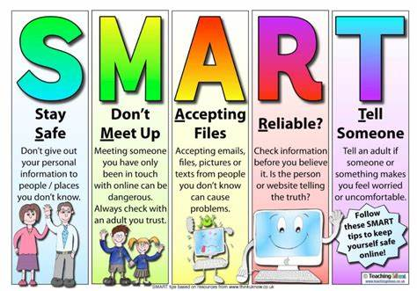
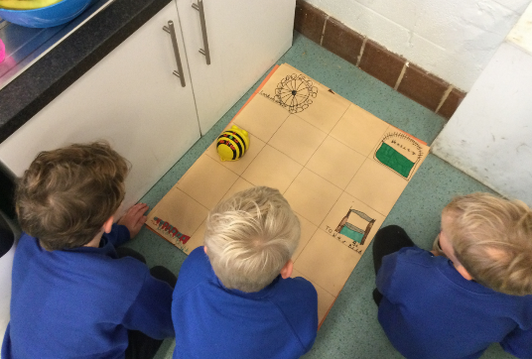
We have incredibly eager technological minds in our school whether we are looking at programming directions with Bee-Bots or writing code to create fun, new games every child shows a high willingness to learn and create. At Owslebury Primary School we follow the National Curriculum which aims to equip young people with the knowledge, skills and understanding they need to thrive in the digital world of today and the future. The curriculum ensures that a variety of skills and topics are covered, including online safety, which is a high priority. The children are taught how to be safe online with a fun pneumonic: SMART.

The computing curriculum can be broken down into 3 strands:
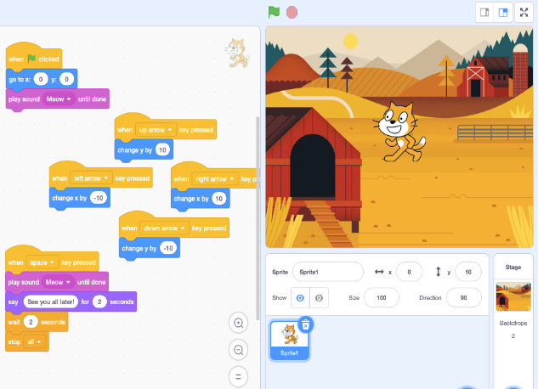
- Computer science – which includes understanding algorithms, data represented in different ways.
- Information technology – where they are evaluating and applying their computer knowledge to solve problems
- Digital literacy – they are responsible, competent, confident and creative users of information and communication technology.

